Brainstorming Report

Final Assignment

Group 56

Bas Schleijpen -

Luke Houben - 1000068

Sander van de Ven - 1002954

# Initial brainstorm session

For this assignment we started the way we started previous assignment: by having a brainstorm session where we talked about our first ideas for this new *thermostat app.* There was one thing where we immediately agreed on, namely that we were going to create this application in HTML5, rather than creating an Android app. This because two out of three people in our group already had some sort of experience with web development, but no one had experience with Android apps. Thus for the sake of time we decided not to start digging into Android development yet.

We quickly decided that a slider is the way to go. It is way easier to use than just a numerical input, and it looks prettier on a display as well. We also decided on dividing our app into three different segments: Live thermostat, Schedule and a Chart page. We didn’t know yet what was going to be on the chart page, but it sounded like a pretty useful feature to have.

Furthermore, we have read more deeply into the assignment description and took note of all the requirements it should have. We then decided that it would be best to create some sketches before we would discuss more things about the app.

# Sketch Review

A week later we came together to discuss and take a look at each other’s sketch(es). Apart from all the general elements that we wanted to have in our design, each sketch had it’s good and bad sides. After discussing the sketches and our ideas behind it, we combined multiple aspects from each sketch into the final version of our program. We then moved on to setting up the project repository and our project setup. We decided to use a fully automated setup using Node.js modules and Grunt/Bower to make changes compile automatically and show up immediately on the page, saving a lot of time. From this moment on there is nothing more invented, and we just started working with our sketches and ideas we had in our heads. A week later the program was almost fully done and only needed some final adjustments which we made together. The sketches can be found in Appendix I.

# Design Decisions

We made some decisions that are not immediately obvious and should be explained before they make sense. Those are noted down here:

* We decided to make the slider curved instead of a straight slider, because of looks and accuracy when used on a small screen (phone).
* We also decided to create a navigation bar at the top of the page instead of a drop-down list, because of the simplicity and easy navigation.
* We also decided to create the schedule by having one tab for each day, together with a separated ‘Reset Schedule’ button. This makes it easy to navigate through the options, while keeping it light on mobile devices.
* Lastly we decided to give the background a subtle color, but not too bright or too ‘deep’. This creates a soft finish of the page, making it pleasant to look at.

# Appendix I - Sketches

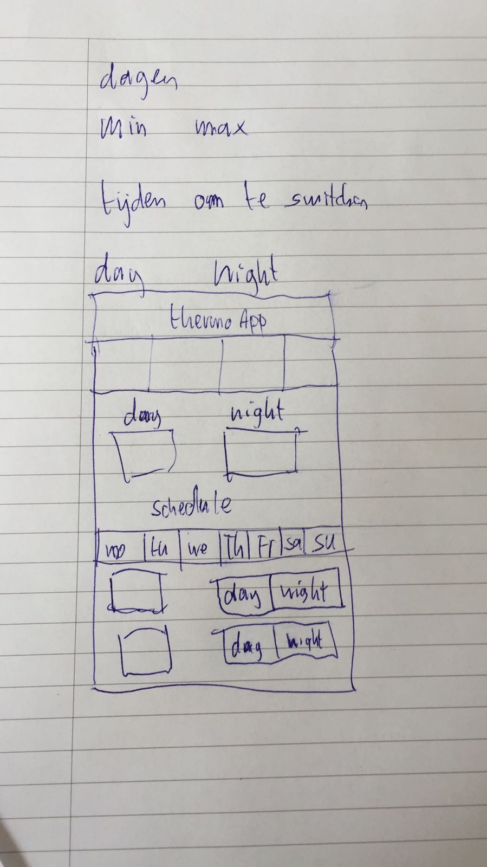

Figure 1 Schedule page overview by Bas

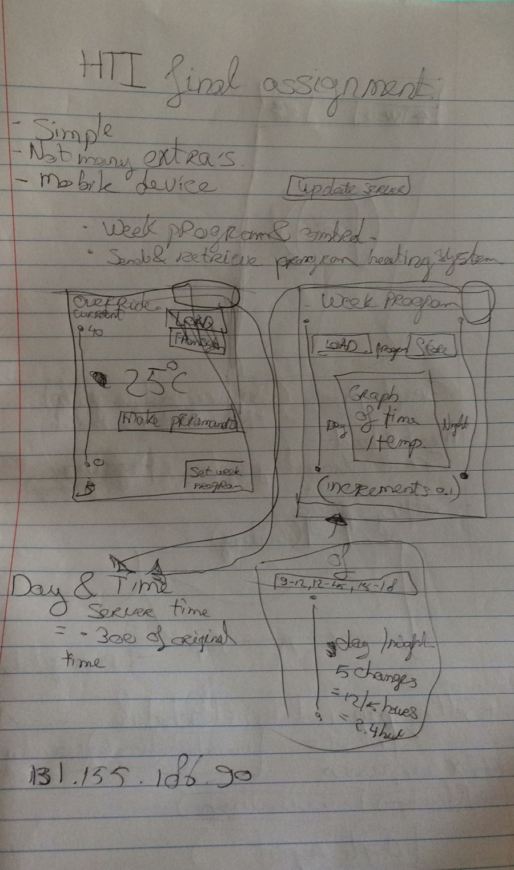

Figure 2 Schedule and live thermostat overview by Sander

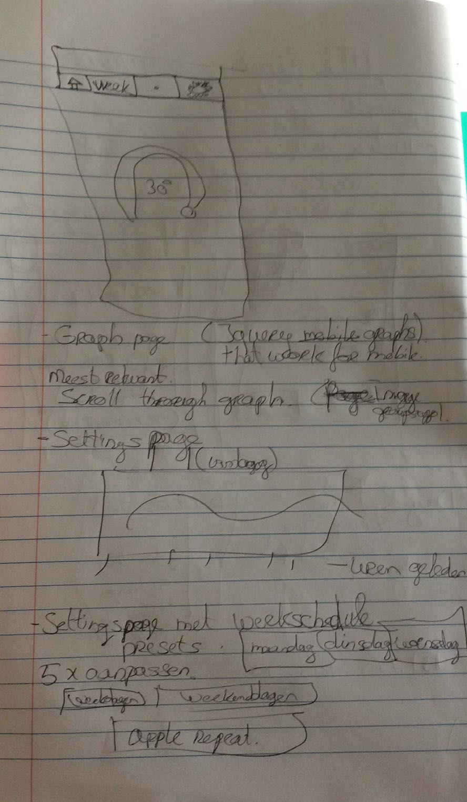

Figure 3 More overviews by Sander

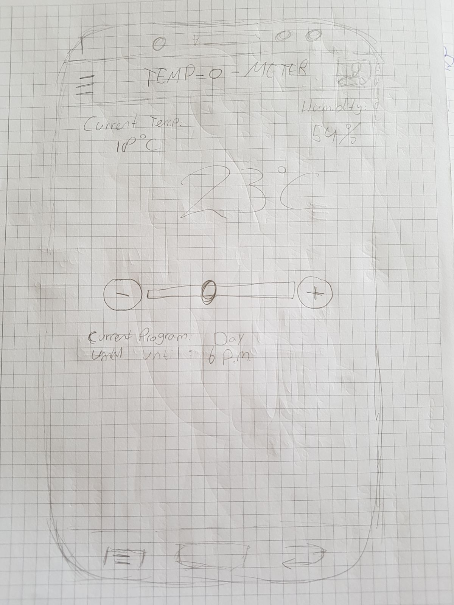

Figure 4 Live Thermostat Overview by Luke

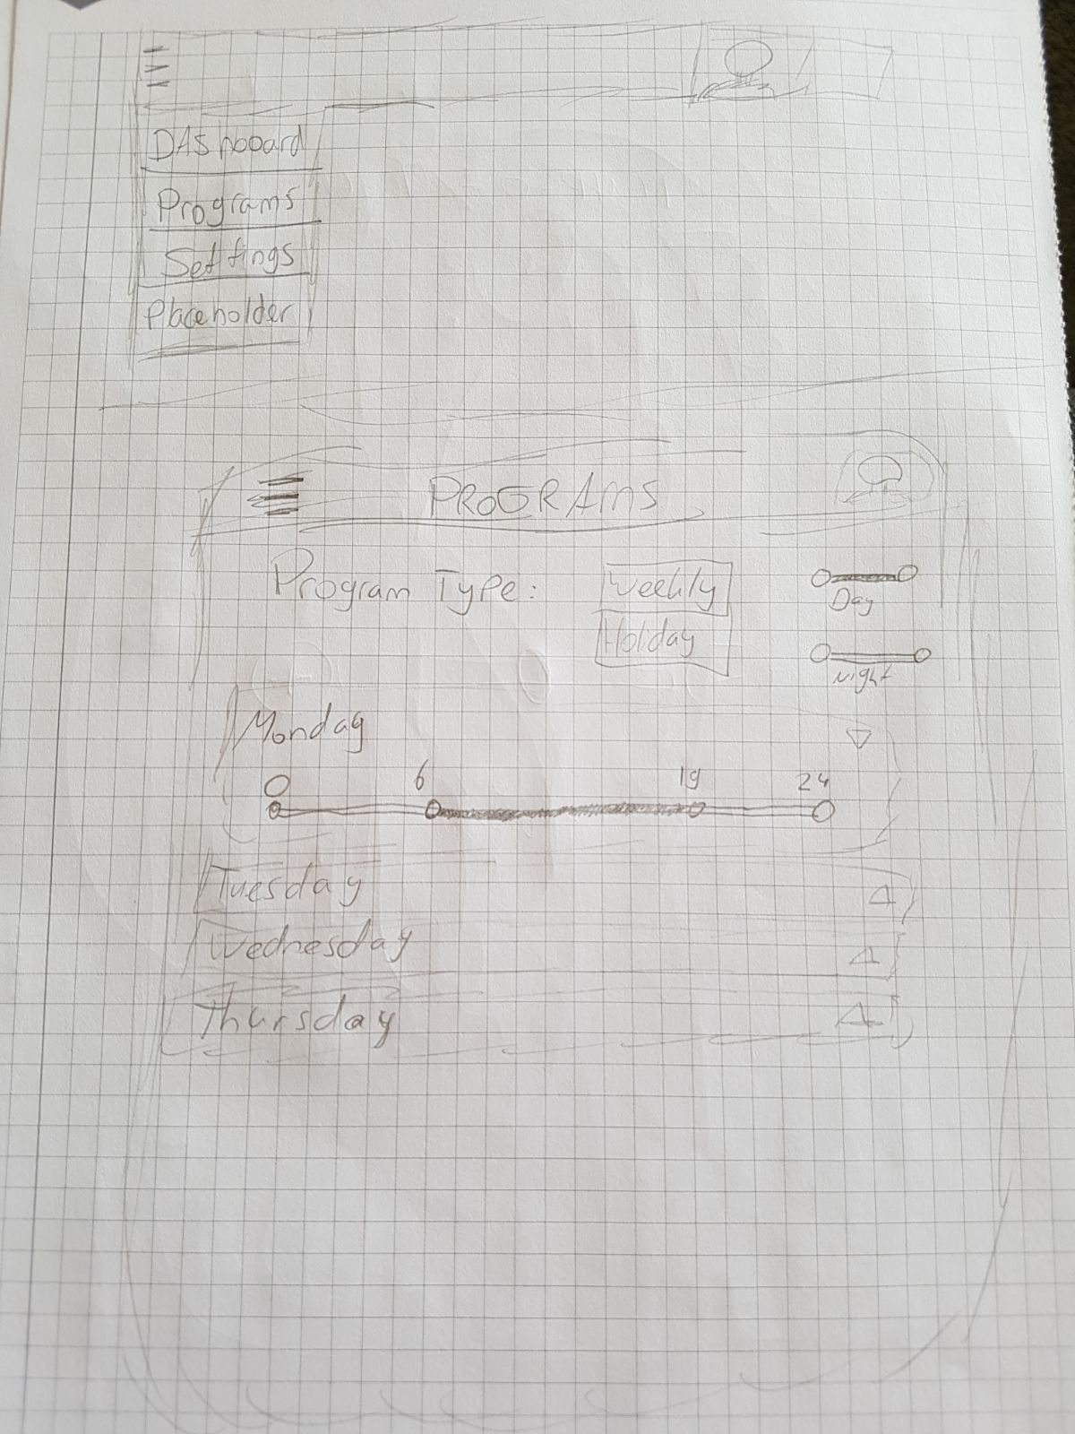

Figure 5 Dropdown and Schedule Overview by Luke